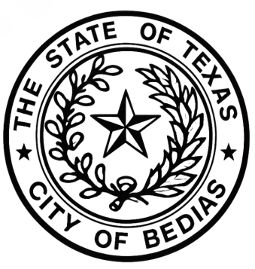
NOTICE OF A CALLED MEETING
CITY OF BEDIAS, TEXAS

MEETING AGENDA
Notice is hereby given that the City Council of the City of Bedias, Grimes County, Texas will meet in Regular Session on June 30, 2026, at 6:00 p.m. at the Bedias Civic Center at 3652 Main Street in Bedias, Texas 77831, at which time the following subjects will be discussed:
- Establish a quorum, call meeting to order, pledges and invocation
- Public Comment Period:
Citizens are ONLY allowed two minutes to speak on any/all Agenda related items ONLY and the speaker form must be completed at least ten minutes prior to the meeting. For Non-Agenda concerns/questions you can speak to the Mayor AFTER the meeting has been adjourned or feel free to come by City Hall at 22251 Leon St, Bedias TX 77831 or call the office Monday through Friday between 8:00 am to 2:00 pm at 936-395-1119.
- Discuss/Consider/Approve: Award of Harvey Reallocation Grant
- Discuss/Consider/Approve: Award/Rejection for CDBG MIT MOD Grant
- Closed Session: The City Council may convene into Closed Session pursuant to Chapter 551 of the Texas Government Code to deliberate regarding personnel matters, legal matters, real property, economic development negotiations, or other matters authorized under the Texas Open Meetings Act.
- Open Session: Reconvene into Open Session and take any action deemed necessary regarding items discussed in Closed Session.

- Adjourn: With no other business the meeting is adjourned.
I, Gwen Boullion, Mayor of the City of Bedias, do hereby certify that a copy of this agenda was posted on the City Hall bulletin board and on the City website in compliance with Chapter 551 of the Texas Government Code on the 26th day of June 2026, at 10:00 a.m.

Gwen Boullion, Mayor Posted: June 26, 2026
City of Bedias, Texas Taken Down:

